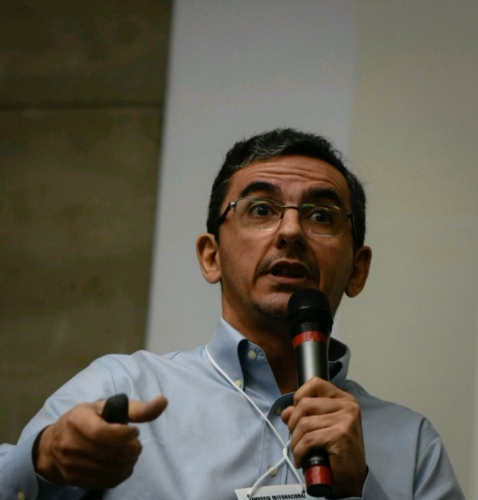

Eduardo Martins
PhD in Civil and Environmental Engineering
Head of Research Institute of Meteorology and Water Resources (FUNCEME)
Professor at Federal University of Ceará (UFC) – Fortaleza, Brazil
presidencia@funceme.br
Dr. Martins´ research has focused on the use of climate information on water allocation and planning, and in the past 10 years his main focus of work is on drought related issues.
Research projects have addressed the value of climate information in water allocation and the climate variability and change impacts on the water sector. Other efforts address calibration and uncertainty analysis for rainfall-runoff models, simulation of water resource systems, and efficient multiple-reservoir system operation considering inflows forecasts.
Particular interests:
- Drought Characterization, Monitoring and Forecasting, Early Warning Systems, Agricultural and Hydrologic Drought, Drought Planning and Policy.
- Statistics in hydrology, optimization and systems engineering
- Use of weather and climate information in water resources, climate variability and change impacts in the water sector.

