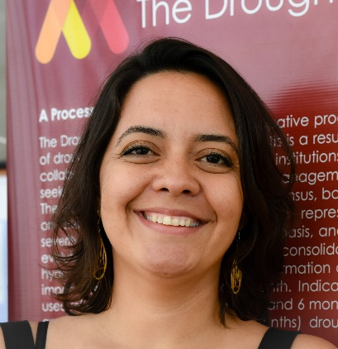

Juliana Oliveira
Researcher | MSc in Physical Sciences applied to Semiarid Regions
Research Institute of Meteorology and Water Resources (FUNCEME)/Federal University of Ceará (UFC) – Fortaleza, Brazil
julianaoliveira@funceme.br
Working in projects focused on the use of climatic information in the management of water resources in Northeast Brazil and in the institutional coordination, operationalization and support studies to the Brazilian Drought Monitor.
Particular interests:
- Drought related issues, drought monitoring and impacts
- Use of weather and climate information in water resources, climate variability and change impacts in the water sector.
- Photography

